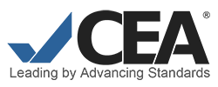
CEA STANDARDS

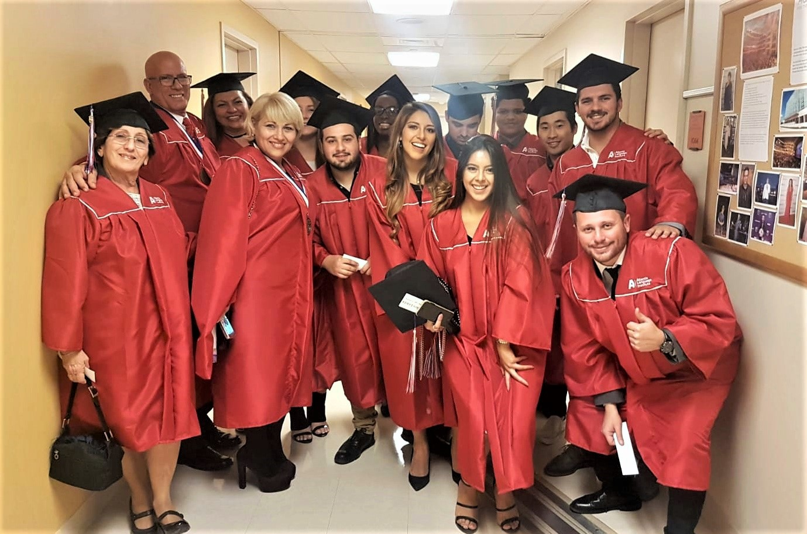

MISSION

Standard 1:
The program or language institution has a written statement of its mission
and goals, which guides activities, policies, and allocation of resources. This statement is communicated to faculty, students, and staff, as well as to prospective students, student sponsors, and the public, and is evaluated periodically.

PROGRAM DEVELOPMENT, PLANNING, AND REVIEW

Standard 1:
The program or language institution has a plan, in writing, for development
of the program or language institution as a whole, including planning, implementation, and evaluation.

Standard 2:
The program or language institution regularly reviews and revises its program components and has plans, in writing, to guide the review of curricular elements, student assessment practices, and student services policies and activities. The plans are systematically implemented.

CURRICULUM

Standard 1:
The curriculum is consistent with the mission of the program or language institution, appropriate to achieve the organization’s goals and meet assessed student needs, and available in writing.
Standard 2:
Course goals, course objectives, and student learning outcomes are written, appropriate for the curriculum, and aligned with each other. The student learning outcomes within the curriculum represent significant progress or accomplishment.

Standard 3: The instructional materials and methodologies are appropriate and supportive of course objectives.

FACULTY

Standard 1:
Faculty members have education and training commensurate with their teaching assignments.
Standard 2:
Faculty have experience relevant to teaching students at the postsecondary level in their areas of assignment and demonstrate an ongoing commitment to professional development.
Standard 3:
Faculty who teach English demonstrate excellent proficiency in English. In language institutions where languages other than English are taught, faculty demonstrate excellent proficiency in the languages they teach.
Standard 4:
Teachers in training are appropriately selected, trained, and supervised for the instructional situations in which they are placed.
Standard 5:
Faculty members each receive a job description and all the terms and conditions of employment in writing at the time they are hired and any time their duties or employment conditions change.
Standard 6:
The program or language institution has an adequate number of faculty, whose duties are structured to permit timely and effective completion.
Standard 7:
The program or language institution describes to faculty clearly and in writing the performance criteria and procedures for evaluation at the onset of the evaluation period; conducts faculty performance evaluations that are systematic, regular, fair, objective, and relevant to achieving program or institutional goals; and conveys evaluation results to faculty in writing in a timely manner.

FACILITIES, EQUIPMENT and SUPPLIES

Standard 1:
The program or language institution has facilities, equipment, and supplies that support the achievement of its educational and service goals; are adequate in number, condition, and availability; and are accessible to students, faculty, and administrators.

ADMINISTRATIVE and FISCAL CAPACITY

Standard 1:
The program or language institution clearly defines and provides a rationale for formal linkages with other entities.
Standard 2:
The program or language institution has an administrative structure and a governance system that are effective in helping it achieve its mission and the mission of the host institution, if applicable. Administrator and staff positions within that structure are adequate in number and staffed with individuals who have appropriate education, training, and experience.
Standard 3:
Administrators and staff members each receive a job description in writing at the time they are hired and any time their duties or employment conditions change.
Standard 4:
The program or language institution defines, encourages, and supports appropriate professional development activities for faculty, administrators, and staff.
Standard 5:
The program or language institution describes to administrators and staff clearly and in writing the performance criteria and procedures for evaluation at the onset of the evaluation period; conducts administrator and staff performance evaluations that are systematic, regular, fair, objective, and relevant to achieving program goals; and conveys evaluation results to administrators and staff in writing in a timely manner.

Standard 6:
Administrators ensure that policies and procedures relating to program or language institution operations are in place, accessible to all who are affected by them, reviewed regularly, and implemented in a timely, fair, systematic, and ethical manner.
Standard 7:
Administrators ensure that there are means for the exchange of information among those who need it.
Standard 8:
The program or language institution documents that it is in compliance with all local, state, and federal laws, as well as with any applicable institutional regulations.
Standard 9:
Financial, student, personnel, program, governmental, and contractual records are maintained and kept current, accessible, complete, accurate and, when appropriate, secure. Reporting is done ethically and in compliance with the law.
Standard 10:
Contracts are in compliance with the law and in keeping with policies of the larger institution, where applicable. Contracts are drafted with appropriate guidance, undergo appropriate review, and are authorized by the appropriate individual(s).
Standard 11:
Financial supervision is conducted by qualified individuals, who implement appropriate policies and procedures and follow accepted accounting practices to ensure the integrity of program or institutional finances.
Standard 12:
Financial reserves are adequate and available to meet obligations to students, staff, and any contractual parties.

STUDENT SERVICES

Standard 1:
Admission policies are consistent with program objectives and with the mission of the program or language institution (and with the host institution if applicable), and are implemented by properly trained and authorized individuals. The admission process ensures that the student is qualified to enroll in and benefit from the instructional program. Both the policies and the personnel who implement them adhere to ethical practices.

Standard 2:
The program or language institution provides academic and personal advising and counseling, as well as assistance in understanding immigration regulations. Such advice and assistance are provided in a timely and accurate manner by qualified individuals.
Standard 3:
The program or language institution provides pre-arrival and ongoing orientation (1) to support students in their adjustment to the program or institution (and to the host institution if applicable) and to the surrounding culture and community and (2) to help them understand immigration regulations and procedures, as well as health and safety issues.
Standard 4:
The program or language institution seeks to ensure that students understand policies regarding enrollment, registration, attendance, repeating levels or courses, and progression through the program of study.
Standard 5:
Students have access to health insurance if required and, in all cases, students are informed about the need for adequate health insurance coverage.
Standard 6:
Students have access to social and recreational activities that provide a cultural context for their language acquisition and other studies, as appropriate.
Standard 7:
The program or language institution clearly states and fulfills its responsibilities regarding student housing.
Standard 8:
The program or language institution clearly states and consistently provides the extent of student services described in any written, electronic, or oral promotional information or in agreements.

RECRUITING

Standard 1:
All program or language institution personnel follow ethical practices for recruiting students and promoting programs, and they ensure that the program or language institution’s policies and procedures are made clear to prospective students and/or student sponsors. In any recruitment transaction, the students' interests and wellbeing are paramount.

Standard 2:
All written, electronic, and oral information used to describe or promote the program or language institution to students and other relevant parties is accurate and complete.
Standard 3:
If a program or language institution has recruiting agreements or contracts with a third party, the program or institution ensures that it has complete information about the third party, assumes responsibility for monitoring the third party, and terminates the agreement if necessary.

LENGTH and STRUCTURE of the PROGRAM OF STUDY

Standard 1:
The calendar states the number of terms per year, the number of weeks per term and the number of hours of instruction per week. The calendar is consistent with and supportive of the program or language institution's stated mission and goals.

Standard 2:
Instructional time is structured to allow students to progress through individual courses and the full program of study as anticipated by the design of the curriculum. Student progression rates are documented and analyzed on a regular basis.

STUDENT ACHIEVEMENT

Standard 1:
The program or language institution has a placement system that is consistent with its admission requirements and allows valid and reliable placement of students into levels.

Standard 2:
The program or language institution documents in writing whether students are ready to progress to the next level or to exit the program of study, using instruments or procedures that appropriately assess the achievement of student learning outcomes for courses taken within the curriculum.

Standard 3:
The program or language institution maintains and provides students with written reports that clearly indicate the level and language outcomes attained as a result of instruction.

Standard 4:
The program or language institution informs students of the assessment procedures used to determine placement, progression from level to level, and completion of the program, as well as their individual results.

STUDENT COMPLAINTS

Standard 1:
The program or language institution makes available to students, in writing, procedures by which they may lodge formal complaints. The program or language institution documents and maintains records of formal student complaints, as well as the resolution of any such complaints.

